NM Id: EEBE86EE697351E9C4F4A83162A5C486

Digital Marketing

**Create a Google My Business Profile**

**Select - Google My Business Profile:**

On clicking the navigation link given the below page appears and then click on the first link.

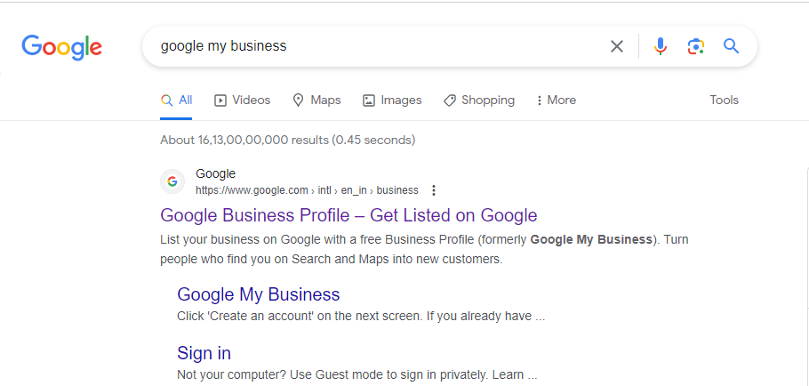

**Sign In:**

The below page appears and click on the “sign in” to proceed further.

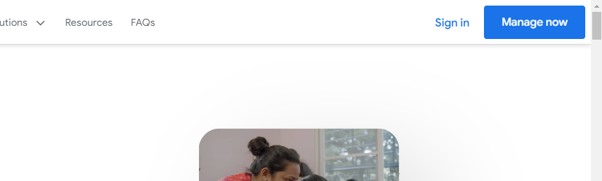

### Business Name:

### As we signed in the business name is given “Frea Bath and Bodyworks” and click “continue”

### 

### Business Type:

### Once the business name is given we choose the business type as “Local Store” and click “Next”

### 

### Business Category:

### The business type is chosen and categorized as “Shop” and to proceed click “Next”.

### 

### Business Address:

### The business address is given below and given “Next” to continue.

### 

### Checking the Business:

### Checking the Business:

### The local stores are listed and we don’t belong to any of the local store so click on “None of these”.

### 

### Check The Location:

### The given location is verified. Click “Next”

### 

### Contact Details:

### Contact Details:

### As it is not needed to give the phone number, we didn’t add the phone number.

### 

### Check Boxes:

### Click the check boxes if you needed and click continue.

### 

### Verification:

### The verification is done to proceed the business account

### 

### Business Hours:

### Business Hours:

### The shop open day and time is mentioned to ease the customer

### 

### Adding Messing Feature:

### 

### The messaging feature is enabled in order to accept the customer queries and click “Next”.

### 

### 

### Business Description:

### Our business description is given in the description box that can be viewed by the customer. Click “Next”.

### 

### Upload Photos:

### The photos of our Products are uploaded. Click “Next”.

### 

### Claim Your Business:

### Advertisement of the shop can be done by the Google Ads.

### 

### Click "Continue":

### 

### 

### Visibility:

### Our Business profile is created and published once the Shop is verified.

### 

<https://www.google.com/search?q=my+business&mat=Ca-e3qeDw7n-EkwBl7_Llz90MmG3opriJ0nTEHYAUuFAxe_uNZW2kWVEpuYhht-Z7geRjCQ_qABJLuOevV-9YYAVrJcDAN4xGjAyN4uutXv9WXFfuPES&hl=en&authuser=0>